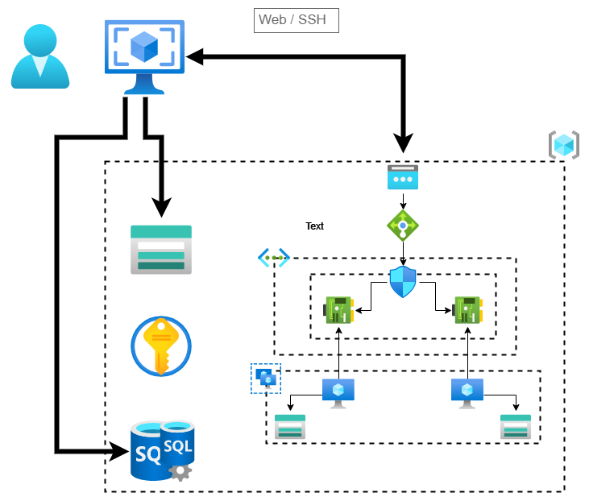

## Development process

* Create resources using Azure portal
  + Create public IP
  + Create virtual network
    - Create one subnet
  + Create load-balancer
    - Add NAT to access port use by SSH and RDP
    - Create Backend / frontend pools
    - Create probs and load balancing rules
  + Create network security group and assign inbound access rules for web, SSH, RDP ports
  + Create Storage accounts for each VM.
  + Create VM and Network interface cards (NIC)
    - Assign NIC to security groups
    - Use custom script extension to install and download files.
      * Install IIS
      * Download and install PowerShell and Dotnet hosting bundle
* Went through each created component and collect Infrastructure as Code (IaC) code and combine them all together to create ARM templet that can use to automate resource deployment. Unnecessary code parts removed as need.
* Create additional resource need to store files and data need by ARM templates
  + Create storage account to store scripts, archive files, Web service zipped file.
  + Create database to store log data
  + Use existing key vault to store secrets

## Steps to setup environment

* Open-SSH client (pre-instaled in Windows 10)
* Setup PowerShell
  + PowerShell 7
  + Install-Module -Name Az
  + Install-Module -Name SqlServer
* Azure pre-setup
  + Azure Account login or Service Principle to access resources
  + Azure key vault with two secrets
    - Secret 1: VM password
    - Secret 2: Email account password
* Open PowerShell and navigate to extracted folder
* Execute Setup-Environment command in DeployResources.ps1 pass required parameters
  + WorkSpace: folder to store generated file when running scripts, Path should be valid.
  + ExtractFolderLocation: path to the extracted folder, Path should be valid
  + ResourceGroupName: Name of the resource group that all resources placed
    - No number, Max 10 characters
  + ResourceGroupLocation: Location of the resource group, should be valid location
  + KeyValtName: name of the Azure Key-Vault
  + VmSecretName: secret name for VM passwords
  + EmailSecretName: secret name for Email password
* Supply Required value when asked
  + From Email address
  + From Email address username
  + To Email address

## Execute Script

* Scripts related to two tasks stored under “ServiceManagementScripts” folder in extracted folder
* To run both scripts there is one mandatory parameter “WorkSpace
  + Workspace: workspace path in previous step/ResoureGroupName-ResourceGroupLocation